The Rise of Luxury Mobility Tourism in the UAE: How High-End Cars Enhance Visitor Experience

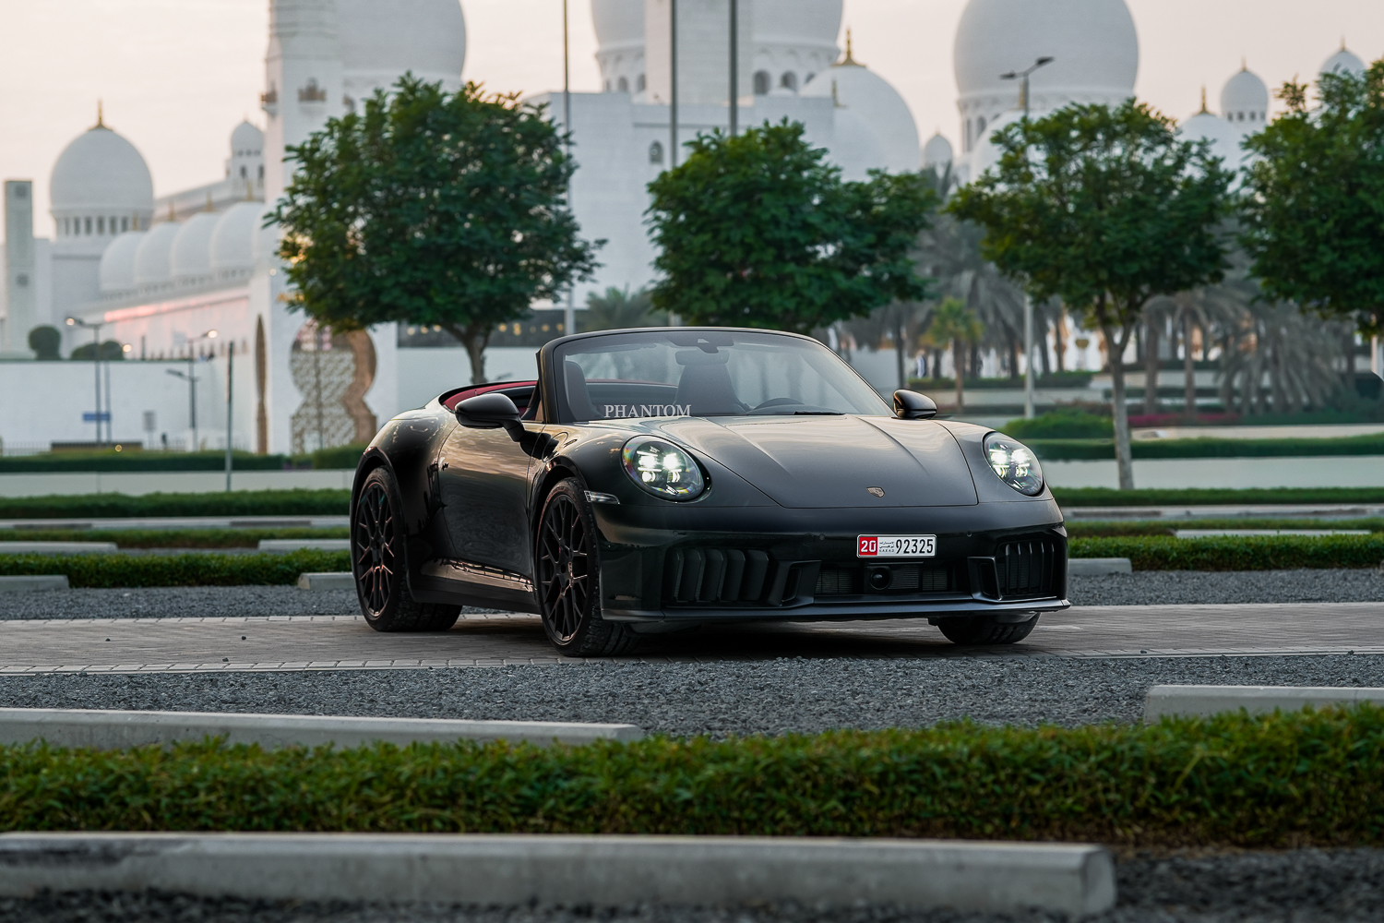
The UAE has always been a hub of tourism. However, recently, a different kind of tourism has emerged, one that has no relation to the pristine beaches, tall skyscrapers, or grand shopping festivals. Instead, focus on how people or visitors choose to explore the country.

Nowadays, more tourists flock to Dubai or the UAE not just to visit the globally renowned touristic spots, but to experience the luxury of some of the world's most renowned cars in one place. Whether they choose to cruise along Sheikh Zayed Road or take a Rolls-Royce to explore the tall skyscrapers and futuristic infrastructure, luxury car tourism is becoming increasingly popular in the UAE.

Since the UAE has always been a center of grandeur, elegance, and ambition, luxury mobility tourism has become the latest addition to its offerings. Tourists nowadays do not just want to travel; they want to feel special, pampered, adventurous, and comforted. Needless to say, sitting behind the steering wheel of a Ferrari or Mercedes is nothing but just that.

Top 8 Reasons Why Luxury Car Tourism Is Transforming The Touristic Experience In The UAE

Luxury Cars Have Turned Into An Experience
Gone are the days when travelling in the UAE was simply about going from one place to the next. The focus has now shifted to making it more appealing, comfortable, stylish, and extravagant.

In turn, traveling to the most iconic places in the country, such as the Burj Khalifa, the Palm Jumeirah, or Yas Island, has become an experience in itself, where travelers take Instagram-worthy pictures, drive one of the world's best cars, and demand attention. So, now they do not just buy luxury cars and swoon over them, but rather, they sit in them in the UAE.

Become A Part Of The UAE's Luxury Lifestyle
UAE and luxury go hand-in-hand. Tourists look to visit the Middle Eastern country and witness the best of what luxury has to offer. Needless to say, driving in a Ferrari, Mercedes, or Bentley further improves their experience, confidence, and presence.

Unlike the common public notion, riding in these cars is not just about showing off, but also about becoming an integral part of the UAE’s internal environment. Consequently, visitors come back to feel the same vibe time and again.

Receive Better Freedom And Flexibility To Explore The UAE
Do you think taking luxury rental cars is only about comfort and convenience?

If yes, think again. Unlike guided bus tours or taxis, renting premium cars provides a heightened sense of independence to travelers. They no longer need to wait or look for rides to get from one place to another or follow any schedule; instead, they are able to explore the places of their choice at their own pace without any interruption.

Subsequently, travellers can explore hidden gems, spontaneous detours, and spend some quiet moments without being in a hurry. Moreover, the powerful engines, advanced navigation system, latest technology, and climate control are unmatched perks for traveling through the country's smooth highways.

Make Special Occasions More Memorable
Many visitors travel to the UAE to celebrate life’s biggest milestones—honeymoons, anniversaries, birthdays, or personal achievements. These moments become even more special when paired with a luxury car experience.
Imagine being proposed to at Palm Jumeirah in a Rolls-Royce, or cutting your birthday cake in the middle of the golden desert at night with a sleek convertible by your side. You could even choose a Porsche rental to add a perfect blend of elegance and excitement to your celebration. Global luxury cars don’t just transport you—they elevate emotions and turn memories into stories you’ll cherish forever.

Set Out On A Safe Adventure
No vacation is complete without memorable adventures in the itinerary. Among the several adventures offered by Dubai and the UAE, nothing matches the thrill of cruising down in a mersarati or Ferrari on a wide road or smooth coast. The best part is that these adventures can be carried out safely by following the country's strict driving regulations.

Overall, you can feel the robust engine, speed, and performance of some of the fastest cars in the world without putting your safety at risk. Consequently, tourists, especially car enthusiasts, prefer to visit the UAE for an adrenaline rush.

Explore The Unseen Deserts And Landscapes Of The UAE
The UAE is often admired for its glamour and state-of-the-art infrastructure, but beyond that, a modern charm lies in the mesmerizing landscape, desert dunes, and long coastal stretches that offer breathtaking views across the horizon.

Although you can enjoy these views either wya, driving in a SUV or convertible is something you will not get anywhere else in the world. These views, pampered feelings, and comfort would be forever etched in your memory.

Grab Attention For Your Social Media Posts
We cannot ignore the crucial role that Instagram, TikTok, and Travel vlogs play in attracting tourists to the UAE and Dubai. Tourists and influencers, in particular, often rent luxury cars to create visually striking and aspirational content.

Tourists live to take photos and make videos by placing a Ferrari or Lamborghini against a golden sunset, or by taking a selfie inside a Rolls-Royce surrounded by tall skyscrapers. These aesthetic moments go viral easily, making the UAE one of the visited destinations in modern times.

Final Words
Luxury car tourism is no longer a passing trend in the UAE; it has become an integral part of the country’s travel culture especially in Dubai, where experiences are designed to feel extraordinary. What was once a simple journey now becomes a statement of style, comfort, and aspiration.
Today, Luxury Car Rental in Dubai is about far more than mobility. It offers adventure, thrill, safety, and emotional value in one seamless experience. As the UAE continues to grow as a global tourism hub, luxury rentals provide travelers with comfort, flexibility, independence, and prestige ensuring every trip feels as unforgettable as the destination itself.

